Name: ________________
Unit 2
Private or Public
Human Right or Corporate Product
Bottled or Tap
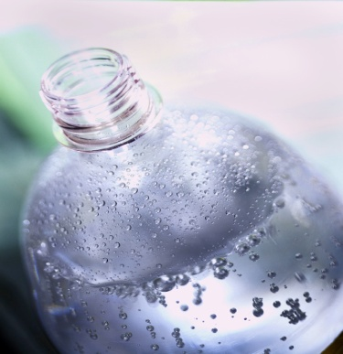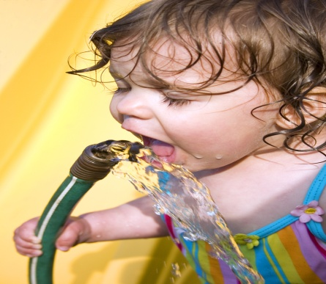
1. _____ 6. _____ 11. _____
2. _____ 7. _____
3. _____ 8. _____
4. _____ 9. _____
5. _____ 10. _____
Extra Credit - _____ Message to the Instructor - ______________________
Total Points for Unit 2 = 430 Unit 2 Grade _____ X .23 = _____
- Watch video Blue Gold. Participate in discussion and decide on your area of concentration. 20 pts.
- Select one of the following options: A. Research one of the largest water companies (Thames, Veolia, etc.) The research should include profits, what they own, their corporate vision, and problems they have had. It should be approximately two pages and it should be formatted as a chart. OR B. Research the UN Resolution on Water and Human Rights. This research should be used to create a fact sheet on this topic with two pages of background, conflict, signatories, and articles on the issue OR C. Research the issue of bottled water. This research should include the following topics: history of the industry, corporate profits, major companies involved, and marketing. Create a two page topical information sheet on the issue. 20 pts.
- Create a fact sheet on private versus public water OR bottled water versus tap water OR human right versus corporate profits. It should have three sections (health, environmental, and ethical) and should include 50 items in the assignment. 25 pts.
- Create an argument about your topic – private or public water, human rights and water, or using bottled water or not. You will be paired with someone who will debate the issue. The debate will be graded with a winner and loser. The grade will be based on research materials and oral argument. You should be prepared to make an opening statement (thesis), prepare five reasons why you are correct, 3 reasons why the other side is reasonable, and a concluding statement. Make sure to include information on the other side of your argument. Research materials 15 pts. Oral arguments 15 pts. The oral debate will be 5 minutes. 30 pts.
- Read one of the following books – Bottled and Sold OR The Story behind Our Obsession with Bottled Water OR Water, the Epic Struggle for Wealth, Power, and Civilization. 1. Take notes in the book and print your notes, 2. Create 10 essential questions in the note section and print, 3. Send 10 messages on social media discussing concepts or passages about the book topic and print, 4. Create a 20 point list of the major points the book makes, 5. Write the thesis of the work, and the counterargument, if there is one, and this should also be printed, 6. Print 10 quotes from the book that you think is important to the thesis or you think is well written. 7. Create or cut and paste and then print an outlined biography of the author or authors (one page). 100 pts.
- Take part in a book discussion of the book you read. You need to speak at least five times and have resources with you to support your ideas. 20 pts.
- Prepare an oral presentation (five minutes) which should have an essential question, your thesis, a history of the situation, five points of support to your thesis, a counter argument with three points, and a conclusion. The presentation should have visuals to support your topic but it is not a PowerPoint presentation. 50 pts.
- Search the NY Times, Time Magazine or the Internet and find a related issue to their topic and read the article. List the thesis, ten points made in the article, the counter argument, and your conclusion on how the two interconnect. 25 pts.
- Create an argument that supports your idea for this unit. You need to create an essential question to answer. Write an outline to support your essay. 20 pts.
- Write an essay on the essential question of bottled water or privatization of water or water as a human right. This essay needs to be correctly cited and fully supported with at least five sources. 100 pts.
- Watch the video Tapped and take part in the discussion. 20 pts.

